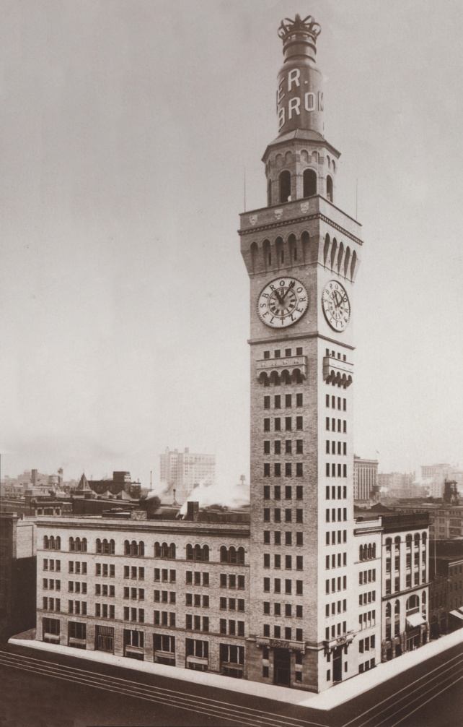
Baltimore’s Historic Bromo Seltzer Arts Tower
History Clock Room Tours
21 South Eutaw Street, Baltimore MD 21202
Groups of 8 or more may schedule a time other than normal Saturday hours to Tour the iconic clock tower in Baltimore. The tower and the clock are listed separately on Baltimore’s Historic registry. Your tour takes you up inside the workings of the largest four dial gravity driven, non chiming clock in the world. The tour begins with an informative power point presentation to learn about the history of the building and Isaac Emerson understand the clock workings and Bromo Seltzer, the product for which it is named. Our museum holds a collection of Bromo seltzer bottles and ephemera . A fun interactive scavenger hunt is available for school groups. Brown Bag Lunch Tours encouraged.
Length of Tour: 45 minutes. Cost: $8.00 per person.
Limited to a minimum of 8 persons and a maximum of 30 persons per tour. Groups of 50-60 may break down into two groups. Allow a minimum of 2 hours for groups of more than 30.
The building is home to 15 floors of artists, writers, sculptors and more, some of which may be open the day of your visit. Feel free to visit them while here.
Note: This 100+ year old building is not handicapped or wheelchair accessible – The last leg up into the tower is a “ships ladder”. A waiver must be signed by each person taking the tour. Children must be accompanied by adults and children’s waivers must be signed by their parent or guardian. Please allot enough time to get your group into the small elevator and to the 15th floor where the tour begins. Allow at least five minute for each 6 persons in the group.
RESERVE NOW! Fill out the form email bstone@promotionandarts.org. For more information call Betsy Stone at 443-874-3596 www.bromseltzerartstower.com
Group Name _______________________________________________________________
Contact Name________________________________________________________________
Contact Email________________________________________________________________
Phone #______________________________________Cell #___________________________
Requested Date of Visit_________________________Time of arrival___________________
# in group______________________ X $8.00 each Total $__________________________
Located on the FREE Charm City Circulator Orange route/ The Light Rail and Metro ,BUS PARKING FACILITY nearby. Near attractions like Orioles Stadium/ Sports Legends. B&O Railroad Museum, Geppi Museum, Edgar Allen Poe’s gravesite , The Irish Railroad Workers Museum, Hippodrome Theater and the Famed Lexington Market.

